Low-Carbon Steels, Long Chipping A36.
Image of Microstructure :
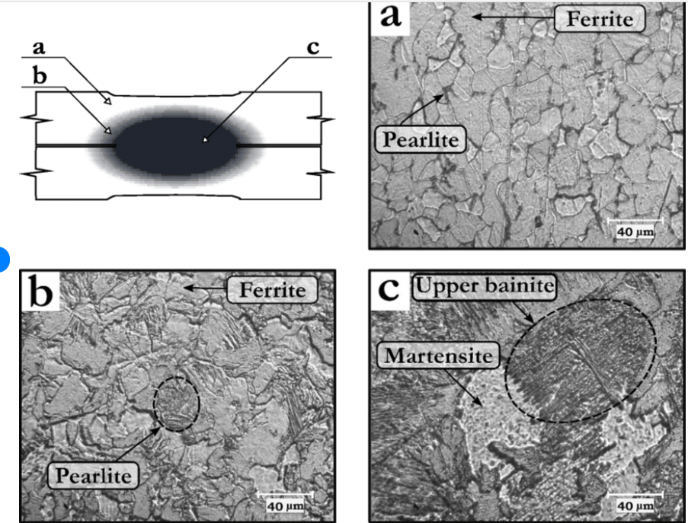

Chemical Analysis :
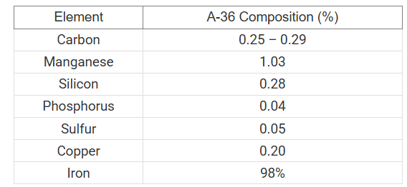

Mechanical Properties for :
-yield strength of 36,000 psI
-ultimate tensile strengths ranging from 58,000 to 79,800 psi.
elongate to about 20% of its original length under tensile testing, providing excellent impact strength at room temperature.
density of 2.84 lb/in^3.
hardness of 67–83 Rockwell.
Machinability rating of 72%.

Supply Range of A36 Steel
-Round Bar: 16-300mm diameter, standard length 6-9 meters.
-Steel Plate: 14-200mm hot rolled available in stock.
-Surface: black surface .
Low-Carbon Steels, Long Chipping 1008
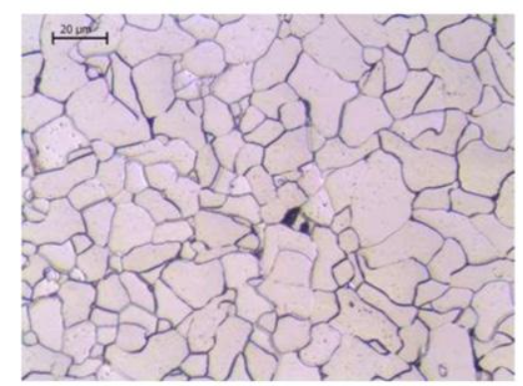

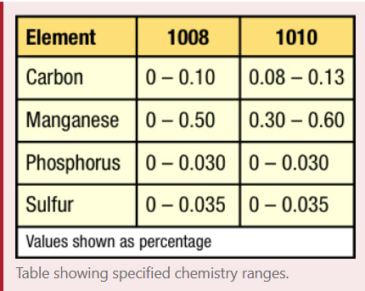
Chemical properties for Low-Carbon Steels, Long Chipping 1008

Mechanical properties for Low-Carbon Steels, Long Chipping 1008
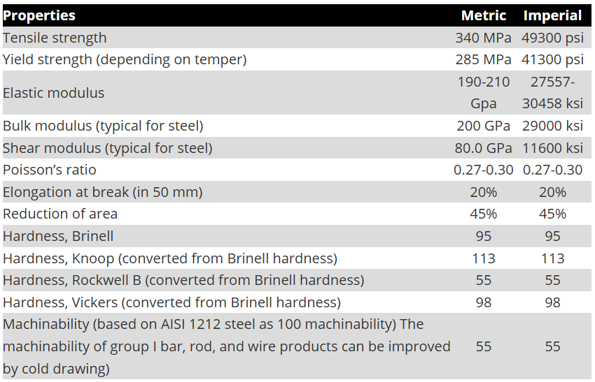

Supply Range of Low-Carbon Steels, Long Chipping 1008

Low-Carbon Steels, Long Chipping 1010
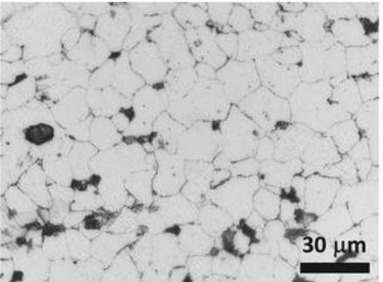
Microstructure for Low-Carbon Steels, Long Chipping 1010

Chemical Properties for Low-Carbon Steels, Long Chipping 1010:
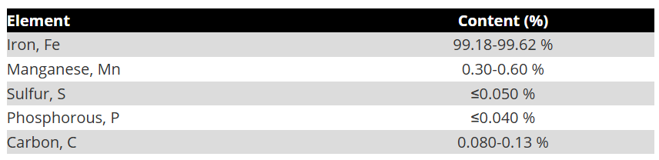

Mechanical Properties for Low-Carbon Steels, Long Chipping 1010 :
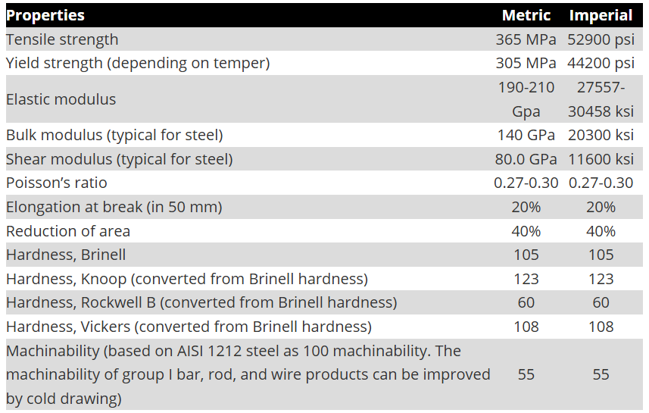

Supply Range of Low-Carbon Steels, Long Chipping 1010 :
Sheet dimension Low-Carbon Steels, Long Chipping 1010
Plate steel:0.1mm to 2500mm.
Width: 10mm to 2500mm.
Tubings: OD: φ6-219 mm, with wall thickness ranging from 1-35 mm.

Low-Carbon Steels, Long Chipping 1018

Microstructure image for Low-Carbon Steels, Long Chipping 1018 :
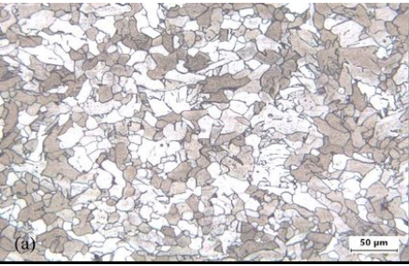

Chemical analysis for Low-Carbon Steels, Long Chipping 1018 :
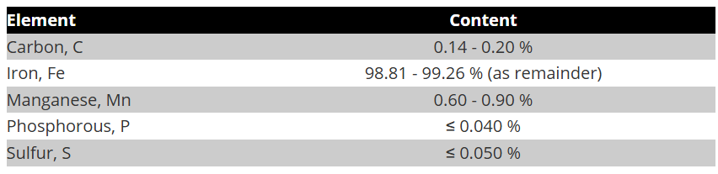

Mechanical Properties for Low-Carbon Steels, Long Chipping 1018:
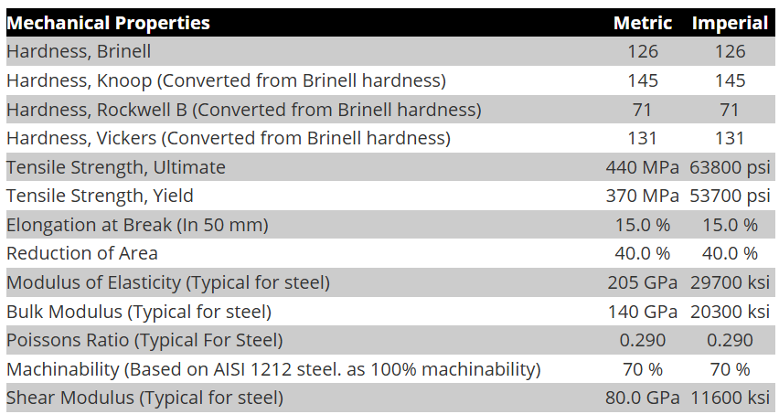
Supply Range of Low-Carbon Steels, Long Chipping 1018:
Dimension Range

- Round Bars:
  - Diameter: 6 mm to 300 mm (0.25 in to 12 in)
- Square Bars:
  - Side Length: 6 mm to 100 mm (0.25 in to 4 in)
- Flat Bars:
  - Width: 20 mm to 300 mm (0.75 in to 12 in)
  - Thickness: 3 mm to 25 mm (0.125 in to 1 in)
- Plates:
  - Thickness: 3 mm to 100 mm (0.125 in to 4 in)
  - Width: 100 mm to 2000 mm (4 in to 78 in)
  - Length: 2000 mm to 6000 mm (78 in to 236 in)
- Sheets:
  - Thickness: 0.5 mm to 3 mm (0.020 into 0.125 in)

Low-Carbon Steels, Long Chipping 1029
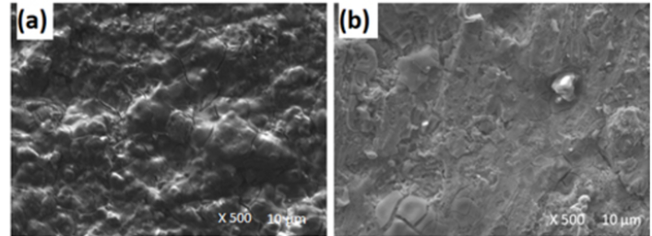
Microstructure image for Low-Carbon Steels, Long Chipping 1029:

Mechanical properties for Low-Carbon Steels, Long Chipping 1029 :
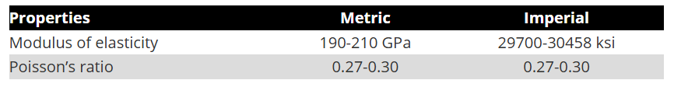
Tensile Strength: Approximately 400-550 MPa (megapascals). This indicates the maximum stress the material can withstand while being stretched or pulled before failure
Yield Strength: Around 250-350 MPa. This is the stress at which the material begins to deform plastically.
Elongation: Typically ranges from 20% to 30%. This property measures the material’s ability to deform under tensile stress, indicating ductility.
Hardness: Generally, falls within the range of 120-180 HB (Brinell hardness), depending on the specific heat treatment.

Chemical analysis for Low-Carbon Steels, Long Chipping 1029 :
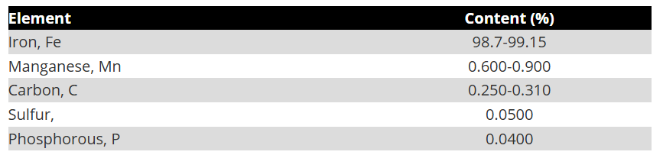

Supply Range of Low-Carbon Steels, Long Chipping 1029 :
Round Bars:
Diameter: Typically ranges from 5 mm to 100 mm or more, depending on the application.
Square Bars:
Side Length: Commonly ranges from 5 mm to 100 mm.
Flat Sheets:
Thickness: Usually ranges from 0.5 mm to 10 mm or more.
Width: Can vary widely, often from 100 mm to 2000 mm or more.
Length: Typically ranges from 1000 mm to 6000 mm.
Plates:
Thickness: Generally, ranges from 5 mm to 50 mm or more.
Width and Length: Similar to flat sheets, but often available in larger dimensions.
Wire:
Diameter: Commonly ranges from 0.5 mm to 10 mm.

Low-Carbon Steels, Long Chipping 1108
Microstructure image for Low-Carbon Steels, Long Chipping 1108 :

Chemical analysis for Low-Carbon Steels, Long Chipping 1108:
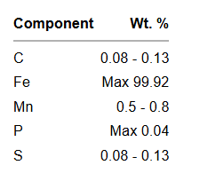
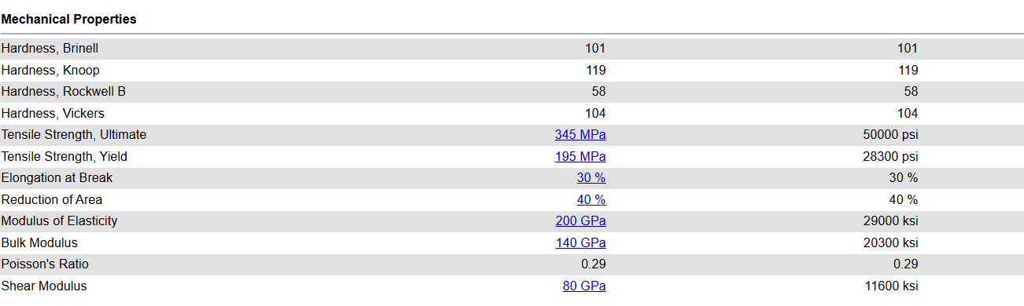
Mechanical properties for Low-Carbon Steels, Long Chipping 1108

Supply Range of Low-Carbon Steels, Long Chipping 1108 :
:

- Bars:
  - Shape: Round, square, or rectangular.
  - Dimensions: Common diameters for round bars range from 6 mm to 100 mm, while square and rectangular bars can vary in size based on application requirements.
- Sheets:
  - Shape: Flat sheets.
  - Dimensions: Thickness can range from 0.5 mm to 25 mm, with standard sheet sizes often being 1000 mm x 2000 mm or 1250 mm x 2500 mm.
- Plates:
  - Shape: Flat plates.
  - Dimensions: Thickness typically ranges from 5 mm to 100 mm, with various lengths and widths available based on customer specifications.
- Coils:
  - Shape: Rolled coils.
  - Dimensions: Thickness can range from 0.5 mm to 3 mm, with coil widths typically around 1000 mm to 1500 mm.
- Pipes and Tubes:
  - Shape: Hollow cylindrical shapes.
  - Dimensions: Outer diameters can range from 10 mm to 500 mm, with wall thicknesses varying based on pressure requirements.
- Forgings:
  - Shape: Custom shapes based on specific applications.
  - Dimensions: Varies widely depending on the part being forged, often tailored to meet specific engineering requirements.

Low-Carbon Steels, Long Chipping 1117

Low-Carbon Steels, Short Chipping, Free Machining 10L18
Microstructure image for Low-Carbon Steels, Short Chipping, Free Machining 10L18 :
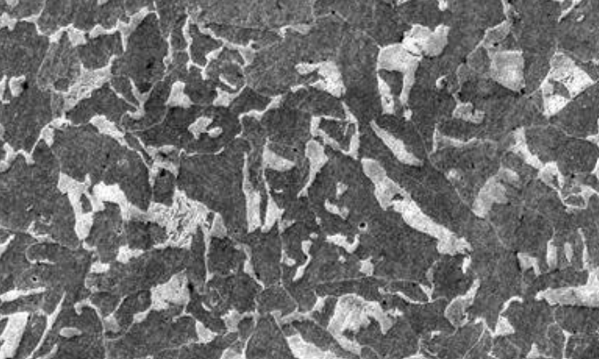

-Chemical analysis for Low-Carbon Steels, Short Chipping, Free Machining 10L18 :

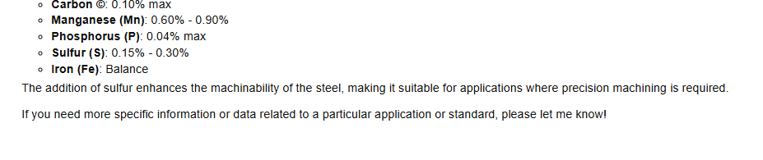
-The machinability rating value for 10L18 steel approximately 100% .
- The Formability rating value for 10L18 steel approximately 100%

- Mechanical properties for Low-Carbon Steels, Short Chipping, Free Machining 10L18 :
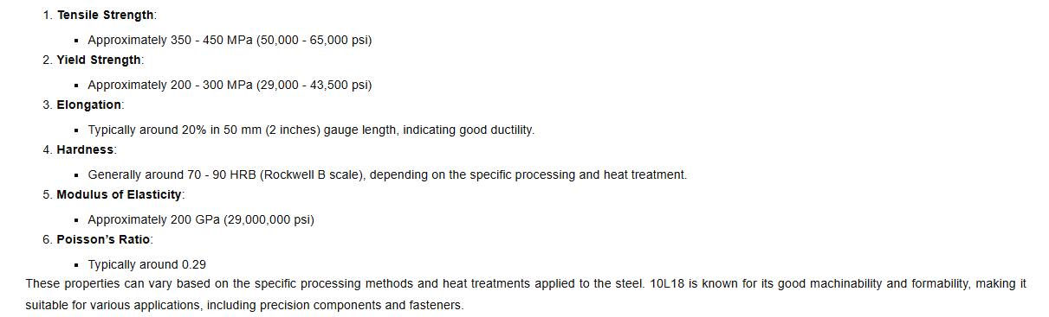

Supply Range of Low-Carbon Steels, Long Chipping 10L18 :
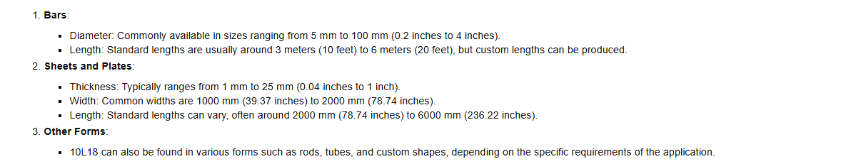

Low-Carbon Steels, Long Chipping 1200 :

Microstructure image for Low-Carbon Steels, Long Chipping 1200 :
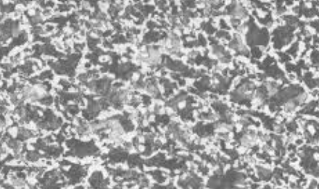

Chemical analysis for Low-Carbon Steels, Long Chipping 1200 :

Carbon (C): ≤ 0.09%. This very low carbon content makes the steel soft and ductile, contributing to the "long-chipping" behavior.
Manganese (Mn): 0.75% – 1.05%. Manganese combines with sulfur to form inclusions that improve machinability and increase tensile strength.
Phosphorus (P): 0.04% – 0.12%. Phosphorus increases the strength and hardness of the ferrite, which helps in obtaining a smoother surface finish.
Sulfur (S): 0.25% – 0.35%. High sulfur content is critical for free-machining, as it facilitates chip formation and reduces tool wear.
Iron (Fe): Balance (typically 98% – 99%).

Mechanical Properties for Low-Carbon Steels, Long Chipping 1200 :
Tensile Strength: Low-carbon steels generally have a tensile strength ranging from 370 to 700 MPa (megapascals).

Yield Strength: The yield strength is usually between 250 to 450 MPa, depending on the specific grade and processing of the steel.

Elongation: Low-carbon steels exhibit good ductility, with elongation values typically ranging from 20% to 30% in a standard tensile test.

Hardness: The hardness of low-carbon steels can vary, but it is generally in the range of 120 to 180 HB (Brinell hardness).

Impact Toughness: These steels have good impact toughness, which is essential for applications where resistance to sudden forces is required.

Weldability: Low-carbon steels are highly weldable, making them suitable for various fabrication processes.

Machinability Rating : 70-80% compared to standard reference material .

Formability Rating: Low-carbon steels are known for their excellent formability.

Supply Range of Low-Carbon Steels, Long Chipping 1200 :
- Bars and Rods:
  - Diameter: Typically ranges from 5 mm to 100 mm.
  - Length: Common lengths are 3 m, 6 m, or custom lengths as required.
- Sheets and Plates:
  - Thickness: Usually ranges from 0.5 mm to 25 mm.
  - Width: Common widths are 1000 mm, 1250 mm, or 1500 mm.
  - Length: Standard lengths can be 2000 mm, 2500 mm, or custom lengths.
- Pipes and Tubes:
  - Diameter: Ranges from 15 mm to 600 mm for standard pipes.
  - Wall Thickness: Typically ranges from 1 mm to 20 mm.
- Structural Shapes:
  - Common shapes include I-beams, channels, and angles.
  - Dimensions vary widely based on the specific shape and application, often defined by industry standards.

Low-Carbon Steels, Short Chipping, Free Machining 1213

Microstructure image for Low-Carbon Steels, Short Chipping, Free Machining 1213 :

Chemical analysis for

Low-Carbon Steels, Short Chipping, Free Machining 12L14.

Microstructure image for Low-Carbon Steels, Short Chipping, Free Machining 12L14:
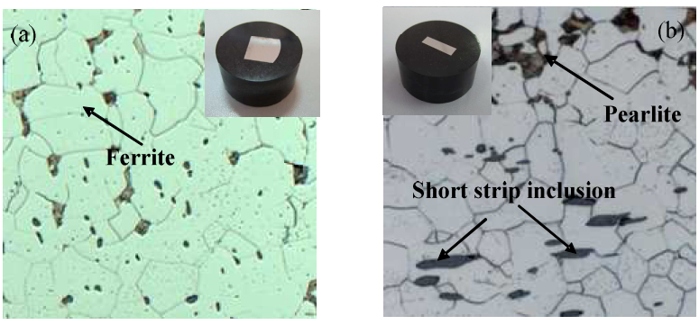

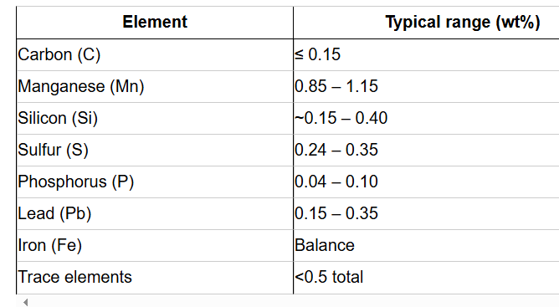
Chemical analysis for Low-Carbon Steels, Short Chipping, Free Machining 12L14 :

Mechanical properties (typical) for Low-Carbon Steels, Short Chipping, Free Machining 12L14
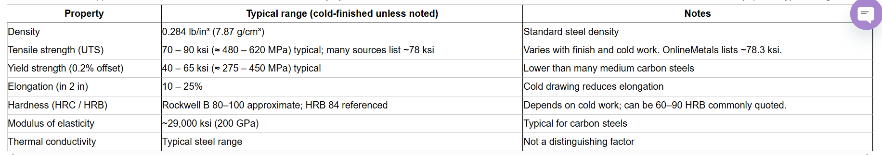
Supply Range of Low-Carbon Steels, Short Chipping, Free Machining 12L14:
- Diameter: Commonly available in round bars ranging from 0.25 inches (6.35 mm) to 6 inches (152.4 mm) in diameter.
- Thickness: For flat bars, thickness can range from 0.125 inches (3.175 mm) to 2 inches (50.8 mm).
- Width: Flat bars can have widths ranging from 1 inch (25.4 mm) to 12 inches (304.8 mm) or more, depending on the supplier.
- Length: Standard lengths for bars are typically 12 feet (3.66 meters) or 20 feet (6.1 meters), but custom lengths can often be ordered.
- Applications: 12L14 is often used for precision machining applications due to its excellent machinability and low cost.

Medium- and High-Carbon Steels 1035
Microstructure image for Medium- and High-Carbon Steels 1035 :
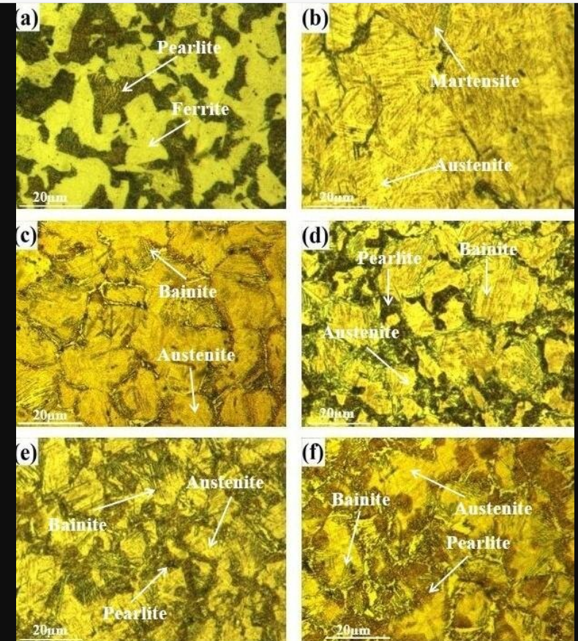

Chemical analysis for Medium- and High-Carbon Steels 1035 :
- Carbon ©: Approximately 0.30% to 0.38%
- Manganese (Mn): Approximately 0.60% to 0.90%
- Phosphorus (P): Maximum 0.04%
- Sulfur (S): Maximum 0.05%
- Iron (Fe): Balance.
Mechanical properties for Medium- and High-Carbon Steels 1035 :
Tensile Strength: Approximately 570 - 700 MPa (82,000 - 101,500 psi)
Yield Strength: Approximately 350 - 450 MPa (50,000 - 65,000 psi)
Elongation: Approximately 16% - 20% in 50 mm (2 inches)
Hardness: Typically around 150 - 200 HB (Brinell Hardness) in the as-rolled condition; can increase significantly with heat treatment.
Modulus of Elasticity: Approximately 200 GPa (29,000,000 psi)
Machinability Rating: approximately 60% compared to the standard reference material .
Formability Rating: 1035 steel exhibits moderate formability.
Supply Range for Medium- and High-Carbon Steels 1035:
- Bars:
  - Diameter: Typically available in round bars ranging from 10 mm to 300 mm (0.39 inches to 11.81 inches).
  - Length: Standard lengths are usually 3 meters to 6 meters (10 feet to 20 feet), but custom lengths can be produced.
- Plates:
  - Thickness: Common thicknesses range from 5 mm to 100 mm (0.20 inches to 3.94 inches).
  - Width: Typically available in widths of 1000 mm to 3000 mm (39.37 inches to 118.11 inches).
  - Length: Standard lengths can vary from 2000 mm to 6000 mm (78.74 inches to 236.22 inches).
- Sheets:
  - Thickness: Generally available in thicknesses from 0.5 mm to 5 mm (0.02 inches to 0.20 inches).
  - Width and Length: Similar to plates, but often available in smaller dimensions.
- Wire:
  - Diameter: Available in wire sizes ranging from 0.5 mm to 12 mm (0.02 inches to 0.47 inches).
  - Length: Typically sold in coils or straightened and cut lengths.
Medium- and High-Carbon Steels 1045,10L45

Microstructure image for Medium- and High-Carbon Steels 1045:
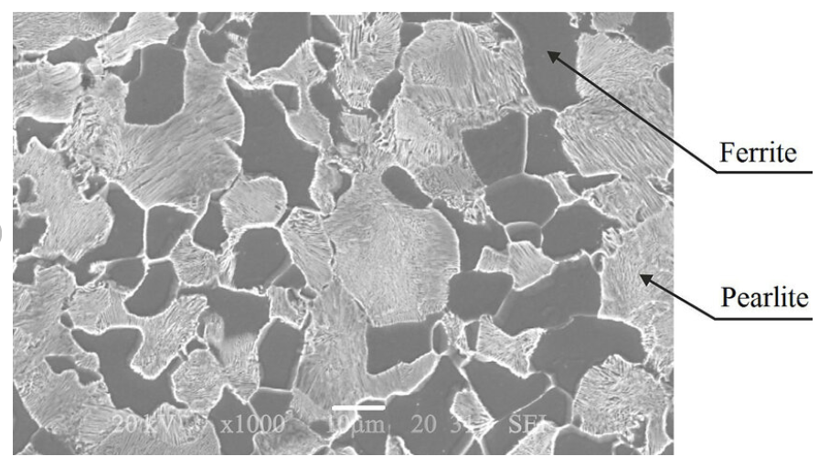

Chemical analysis for Medium- and High-Carbon Steels 1045

- Carbon ©: Approximately 0.43% to 0.50%
- Manganese (Mn): Approximately 0.60% to 0.90%
- Phosphorus (P): Maximum 0.04%
- Sulfur (S): Maximum 0.05%
- Iron (Fe): Balance

Mechanical Properties for Medium- and High-Carbon Steels 1045 :
- Tensile Strength: Approximately 620 - 750 MPa (90,000 - 109,500 psi)
- Yield Strength: Approximately 370 - 450 MPa (54,000 - 65,000 psi)
- Elongation: Approximately 15% - 20% in 50 mm (2 inches)
- Hardness: Typically around 170 - 210 HB (Brinell Hardness) in the as-rolled condition; can increase significantly with heat treatment.
- Modulus of Elasticity: Approximately 200 GPa (29,000,000 psi)
- Machinability Rating: 1045 steel has a machinability rating of approximately 60% to 70% compared to a standard reference material (like 1212 steel, which is rated at 100%). This indicates that it is moderately machinable.
- Formability Rating: 1045 steel exhibits moderate formability. It can be cold worked to some extent, but its formability decreases as the carbon content increases.

Supply Range for Medium- and High-Carbon Steels 1045

- Bars:
  - Diameter: Typically available in round bars ranging from 10 mm to 300 mm (0.39 inches to 11.81 inches).
  - Length: Standard lengths are usually 3 meters to 6 meters (10 feet to 20 feet), but custom lengths can be produced.
- Plates:
  - Thickness: Common thicknesses range from 5 mm to 100 mm (0.20 inches to 3.94 inches).
  - Width: Typically available in widths of 1000 mm to 3000 mm (39.37 inches to 118.11 inches).
  - Length: Standard lengths can vary from 2000 mm to 6000 mm (78.74 inches to 236.22 inches).
- Sheets:
  - Thickness: Generally available in thicknesses from 0.5 mm to 5 mm (0.02 inches to 0.20 inches).
  - Width and Length: Similar to plates, but often available in smaller dimensions.
- Wire:
  - Diameter: Available in wire sizes ranging from 0.5 mm to 12 mm (0.02 inches to 0.47 inches).
  - Length: Typically sold in coils or straightened and cut lengths.

Notes:
    - Generally, it has higher tensile and yield strength compared to 10L45 due to its higher carbon content and lack of alloying elements that may reduce strength.
10L45 may have better machinability and formability due to its lower carbon content and the presence of alloying elements.

Medium- and High-Carbon Steels 1050,10L50
Microstructure image for Medium- and High-Carbon Steels 1050,10L50 :
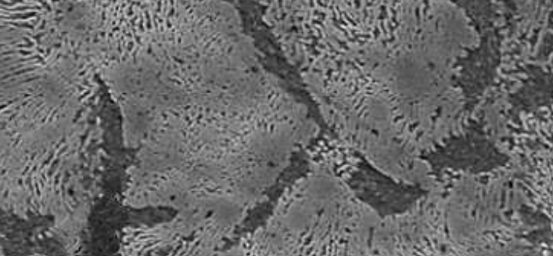

Chemical analysis for Medium- and High-Carbon Steels 1050,10L50 :
- Carbon ©: Approximately 0.48% to 0.55%
- Manganese (Mn): Approximately 0.60% to 0.90%
- Phosphorus (P): Maximum 0.04%
- Sulfur (S): Maximum 0.05%
- Iron (Fe): Balance
Mechanical properties for Medium- and High-Carbon Steels 1050:
- Tensile Strength: Approximately 650 - 850 MPa (94,000 - 123,000 psi)
- Yield Strength: Approximately 400 - 600 MPa (58,000 - 87,000 psi)
- Elongation: Approximately 15% - 20% in 50 mm (2 inches)
- Hardness: Typically, around 170 - 210 HB (Brinell Hardness) in the as-rolled condition; can increase significantly with heat treatment.
- Modulus of Elasticity: Approximately 200 GPa (29,000,000 psi)
- Machinability Rating: 1050 steel has a machinability rating of approximately 60% to 70% compared to a standard reference material (like 1212 steel, which is rated at 100%). This indicates that it is moderately machinable.
- Formability Rating: 1050 steel exhibits moderate formability. It can be cold worked to some extent, but its formability decreases as the carbon content increases.
Supply Range for Medium- and High-Carbon Steels 1050
- Bars:
  - Diameter: Typically, available in round bars ranging from 10 mm to 300 mm (0.39 inches to 11.81 inches).
  - Length: Standard lengths are usually 3 meters to 6 meters (10 feet to 20 feet), but custom lengths can be produced.
- Plates:
  - Thickness: Common thicknesses range from 5 mm to 100 mm (0.20 inches to 3.94 inches).
  - Width: Typically, available in widths of 1000 mm to 3000 mm (39.37 inches to 118.11 inches).
  - Length: Standard lengths can vary from 2000 mm to 6000 mm (78.74 inches to 236.22 inches).
- Sheets:
  - Thickness: Generally available in thicknesses from 0.5 mm to 5 mm (0.02 inches to 0.20 inches).
  - Width and Length: Similar to plates, but often available in smaller dimensions.
- Wire:
  - Diameter: Available in wire sizes ranging from 0.5 mm to 12 mm (0.02 inches to 0.47 inches).
  - Length: Typically sold in coils or straightened and cut lengths.

Medium- and High-Carbon Steels 1080

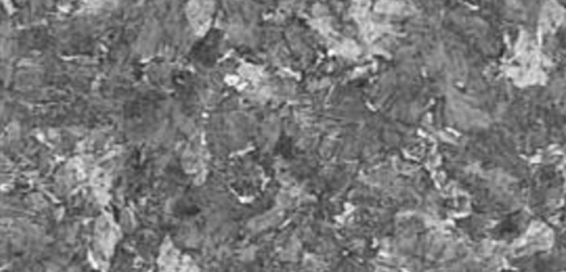
Microstructure image for Medium- and High-Carbon Steels 1080

Chemical analysis for Medium- and High-Carbon Steels 1080
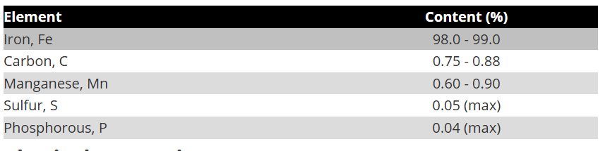
Mechanical Properties for Medium- and High-Carbon Steels 1080
- Its yield strength typically ranges between 390–450 MPa.
- Elastic Modulus: 190–210 GPa
- Poisson’s Ratio: Range: 0.27–0.30.
- Hardness (Rockwell C): After quenching: 50–58 HRC
Softened (annealed): Lower, to improve machinability.
Supply Range for Medium- and High-Carbon Steels 1080
Thickness: Common thicknesses range from 0.5 mm to 25 mm, depending on the application.
Width: Widths can vary widely, often from 25 mm to 2000 mm or more for flat products.
Length: Lengths can also vary, with standard lengths being 2000 mm to 6000 mm for sheets and plates.

Medium- and High-Carbon Steels 1137

Microstructure image for Medium- and High-Carbon Steels 1137 :

